

SOFTWARE REQUIREMENTS SPECIFICATION

Medical Appointment and Health Record
Portal


Prepared for: TECHNOVA SOFTWARE HACKATHON 2026
Date: 31/07/26 – 01/08/2026
Team name: Error 404
Members:
- Keerthana V
- Samritha K
- Praveen Kumar S
- Vengatajalam K

1. Introduction Project Overview
The Medical Appointment and Health Record Portal is a web-based platform that enables hospitals and clinics to manage appointments, maintain electronic health records (EHR), automate administrative tasks, and improve communication between patients, doctors, and hospital staff.
The portal replaces traditional paper-based systems with a secure digital platform that allows patients to schedule appointments online, doctors to access medical histories instantly, administrators to manage hospital operations, and staff to coordinate patient services efficiently.

Problem Statement
Many healthcare institutions continue to rely on manual appointment scheduling and paper-based medical record management. These traditional processes are time-consuming, prone to human error, and inefficient, leading to operational challenges for both healthcare providers and patients.
Since many hospitals still rely on manual appointment booking and paper-based medical records. It leads to:
- Long waiting times
- Lost or damaged records
- Duplicate patient information
- Poor communication
- Delays in treatment
- Inefficient workflow
There is a need for an integrated digital platform that streamlines appointments, securely stores medical records, automates routine processes, and improves healthcare services.

Objectives
- Digitize appointment scheduling.
- Maintain secure electronic health records.
- Provide role-based access.
- Automate appointment reminders.
- Generate reports and analytics.
- Improve transparency.
- Reduce paperwork.
- Enhance patient satisfaction.

Scope of Project
The system supports:
- Patient Registration
- Online Appointment Booking
- Doctor Schedule Management
- Electronic Health Records
- Prescription Management
- Billing Information (Invoice)
- Notifications
- Reports
- Admin Dashboard

2. System Overview Brief Description
The Medical Appointment and Health Record Portal provides centralized management of appointments and medical records.
Patients can:
- Register
- Login
- Book appointments
- View prescriptions
- Access medical history
Doctors can:
- View appointments
- Update diagnoses
- Upload prescriptions
- Access patient records
Hospital staff manage appointments while administrators monitor the entire system.

Users and User Roles:

Target Users | User Role
Patient | Book appointments and view records
Doctor | Manage appointments and health records
Receptionist | Schedule appointments
Staff | Maintain records
Administrator | Manage system

Key Features
- Online Appointment Booking
- Doctor Recommendation
- Electronic Medical Records
- Doctor Availability
- Prescription Upload
- Patient Dashboard
- Admin Dashboard
- Staff Management
- Notifications
- Secure Login
- Role-Based Access Control

Hardware Requirements
- Computer/Laptop
- Smartphone
- Internet Connection
- Cloud Server

Software Requirements Frontend
- React.js

Backend
- Node.js
- Express.js
Database
- MySQL
Authentication
- Bcrypt Authentication

Cloud
• Firebase (Notifications)

3. System Requirements

Functional Requirements

Patient
- Register/Login
- Book Appointment
- Cancel Appointment
- View Medical History
- View Prescriptions & Receive Notifications
Doctor
- Login
- View Schedule
- Update Patient Records
- Add Diagnosis
- Upload Prescription
Receptionist
- Manage Patient Registration
- Update Appointments
- View Schedule
- Receive Notifications

Admin
- Manage Users
- Manage Doctors
- Monitor System

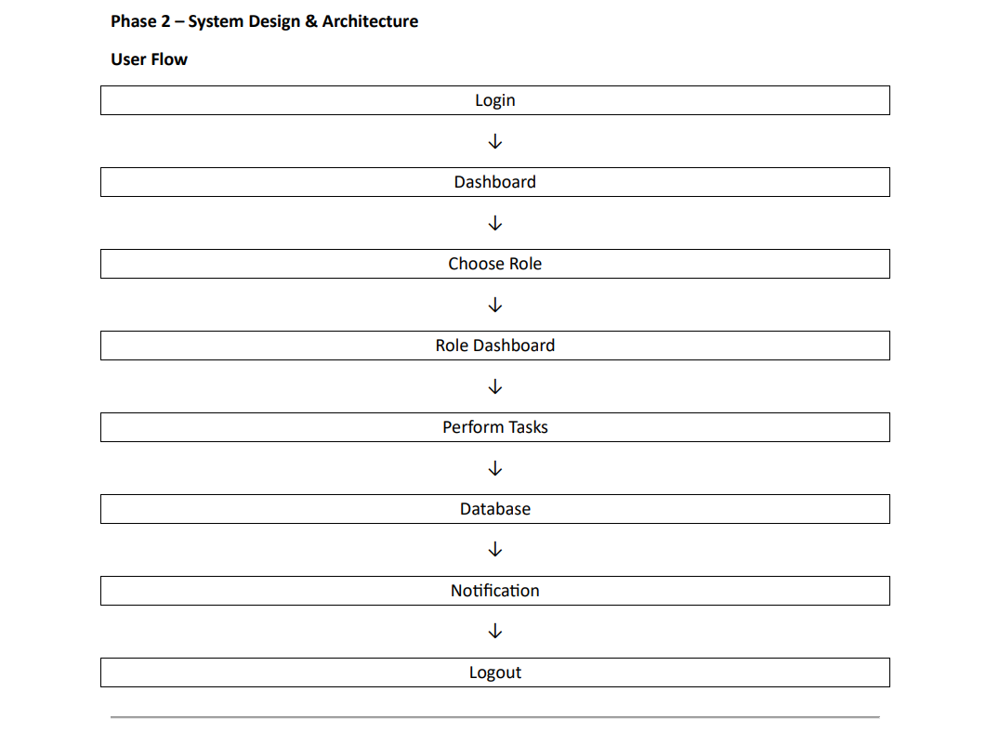

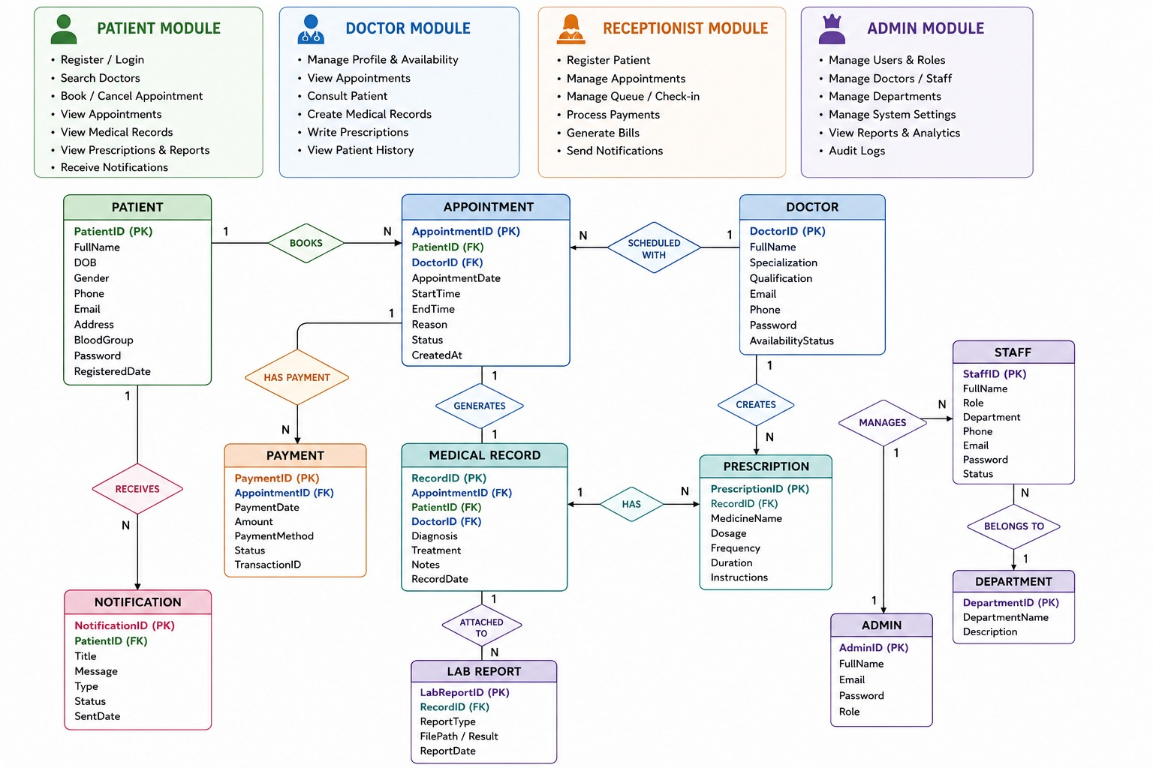
ER Diagram:

Non-Functional Requirements
- High Availability
- Secure Authentication
- Fast Response Time
- Data Encryption
- Scalability
- Reliability
- Backup & Recovery
- Cross-browser Support
API Planning Example APIs
• POST /login
• POST /register
• GET /appointments
• POST /appointments
• PUT /appointments/:id
• DELETE /appointments/:id
• GET /patients
• POST /medical-record
• GET /prescriptions
• POST /billing
• GET /notifications

4. Technologies Used
Layer | Technology
Frontend | React.js
Backend | Node.js
Framework | Express.js
Database | MySQL
Authentication Bcrypt
Notifications Firebase Cloud Messaging
Hosting Render / AWS opo
Version Control GitHub

5. Use Case Diagram Actors
- Patient
- Doctor
- Receptionist
- Administrator

Patient Use Cases
- Register
- Login
- Book Appointment
- Cancel Appointment
- View Reports
- View Medical Records

Doctor Use Cases
- Login
- View Patients
- Add Diagnosis
- Upload Prescription
- Manage Schedule

Admin Use Cases

- Add Doctors and Other Staff

- Moderate System

6. System Architecture
Frontend (React)
↓
Backend (Node.js + Express)
↓
Authentication (bcrypt)
↓
MySQL Database
↓
Firebase Notifications
↓
Patient / Doctor / Staff / Admin

7. Database Design Users
- User_ID
- Name
- Email
- Password
- Role
- Phone

Patients
- Patient_ID
- User_ID
- Blood Group
- Age
- Gender
- Address

Doctors
- Doctor_ID
- Name
- Department
- Specialization
- Experience

Appointments
- Appointment_ID
- Patient_ID
- Doctor_ID
- Date
- Time
- Status

Medical Records
- Record_ID
- Patient_ID
- Doctor_ID
- Diagnosis
- Prescription
- Test Reports
- Visit Date

Notifications
- Notification_ID
- User_ID
- Message
- Status

8. User Interface
Main Screens
- Login
- Registration
- Patient Dashboard
- Doctor Dashboard
- Appointment Booking
- Medical Records
- Prescription
- Reports
- Admin Dashboard
- Notifications

9. Assumptions and Constraints Assumptions
- Users have internet access.
- Doctors update records regularly.
- Patients provide correct information.

Constraints
- Secure handling of patient data.
- Internet required.
- Compliance with privacy regulations.

10. Future Enhancements
- AI-based Disease Prediction
- Online Video Consultation
- AI Chatbot
- Medicine Reminder
- Insurance Integration
- Lab Test Booking
- Voice-based Appointment Booking

11. Development Phases
- Requirement Analysis
- System Design
- Database Design
- Frontend Development
- Backend Development
- Testing
- Deployment
- Maintenance

OUTPUT:
